**Practical No. 10**

**AIM : Creatye a mobile network using Cell Tower, Central Office Server, Web browser and WebServer , Simulate connection between them**

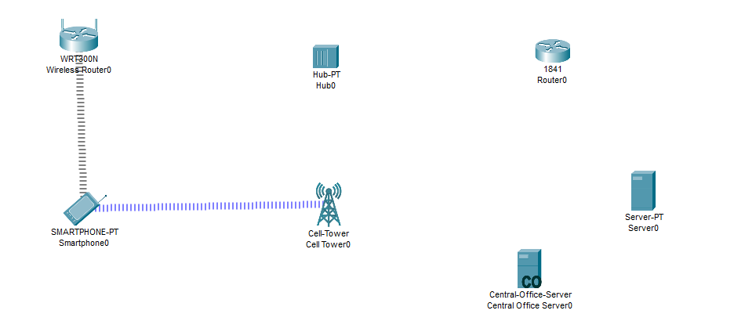

Click on the wireless router and go to config and then select static and the type the ip

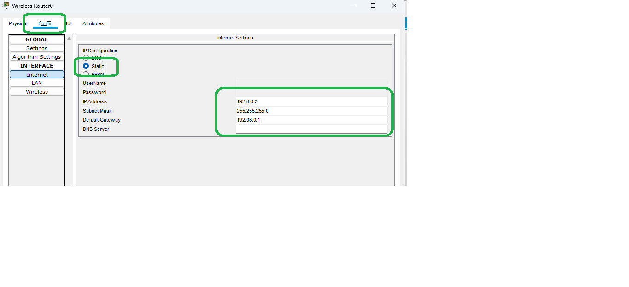

Then select the router and then go to config and then go to the Ethernet then add ip and then click on

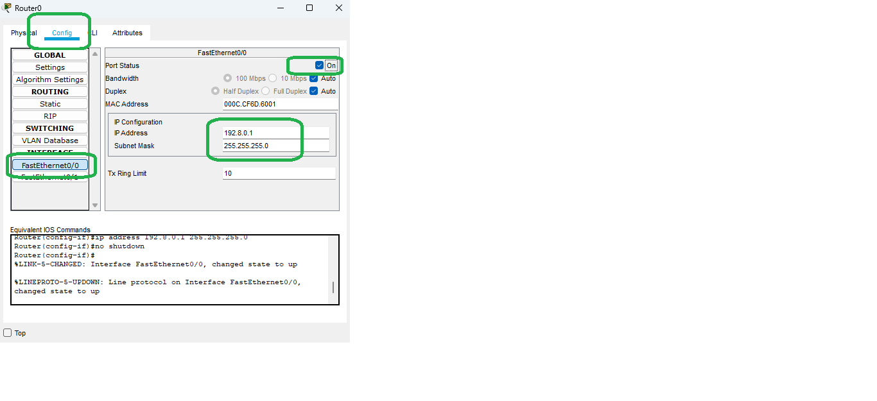0